**Understanding the Difference Between On-Premises, IaaS, PaaS, and SaaS in Cloud Computing**

**Cloud computing:**

**Cloud computing** is the delivery of computing services—including servers, storage, databases, networking, software, analytics, and intelligence—over the internet (“the cloud”) to offer faster innovation, flexible resources, and economies of scale. Instead of owning and maintaining physical data centers and servers, users can access these services on-demand from cloud providers such as Amazon Web Services (AWS), Microsoft Azure, and Google Cloud Platform.

Cloud computing has revolutionized how businesses manage IT infrastructure and software delivery. As organizations shift from traditional IT systems to cloud-based models, it is essential to understand the core differences between **On-Premises**, **Infrastructure as a Service (IaaS)**, **Platform as a Service (PaaS)**, and **Software as a Service (SaaS)**. This document outlines these deployment and service models with comparisons in control, cost, maintenance, and use cases.

**On-Premises Computing:**

On-Premises (or on-prem) computing refers to software and hardware that are installed and run locally on a company’s own servers and infrastructure.

**Characteristics:**

* The organization is responsible for everything: servers, storage, networking, software, updates, and security.
* Requires physical space and a dedicated IT team for maintenance and operation.

**Advantages:**

* Full control over data, systems, and security.
* Customizable to meet specific internal requirements.
* No dependency on internet connectivity for internal applications.

**Disadvantages:**

* High capital expenditure (CapEx) for infrastructure setup.
* Longer deployment times and higher maintenance costs.
* Scalability is limited by physical resources.

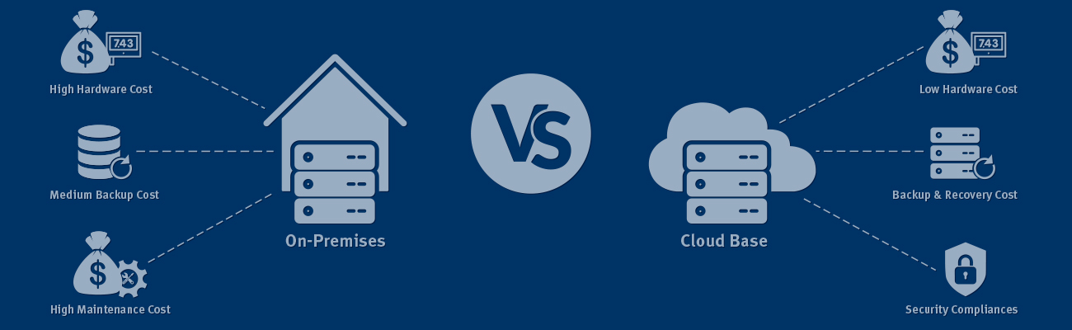

**Infrastructure as a Service (IaaS):**

IaaS provides virtualized computing resources over the internet. It offers infrastructure components like servers, storage, and networking on a pay-as-you-go basis.

### Characteristics:

* Users manage applications, data, runtime, middleware, and OS.
* Providers (e.g., AWS, Azure, Google Cloud) manage virtualization, servers, storage, and networking.

### Advantages:

* Flexible and scalable infrastructure.
* Lower upfront costs compared to on-premises.
* Quick provisioning of resources.

### Disadvantages:

* Requires technical expertise to manage OS and middleware.
* Potential security concerns if not properly configured.

### Common Use Cases:

* Hosting websites and applications.
* Development and testing environments.
* High-performance computing and big data analysis.

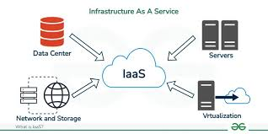

**Platform as a Service (PaaS):**

PaaS delivers a cloud platform and runtime environment for developing, testing, and deploying applications. Developers can focus on code while the provider manages the infrastructure and runtime environment.

### Characteristics:

* Users manage applications and data.
* Providers manage OS, middleware, runtime, and infrastructure.

### Advantages:

* Simplified development process with built-in development tools.
* Faster time to market.
* Scalability and automatic updates handled by the provider.

### Disadvantages:

* Less control over the underlying environment.
* Vendor lock-in risk due to dependency on specific platforms or tools.

### Common Use Cases:

* Developing web or mobile applications.
* API and microservices development.
* Agile development and CI/CD pipelines.

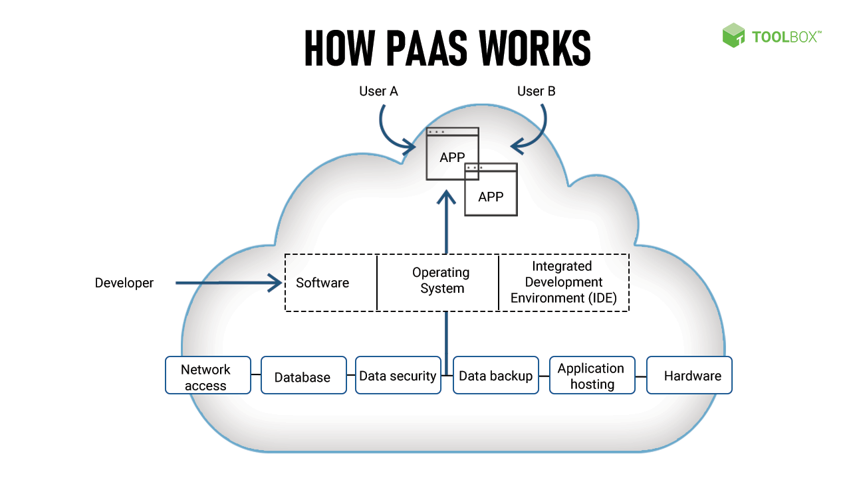

**Software as a Service (SaaS):**

SaaS is a software distribution model where applications are hosted by a provider and accessed by users over the internet.

### Characteristics:

* Users only manage application settings and data.
* Everything else is managed by the provider.

### Advantages:

* No installation or maintenance required.
* Accessible from anywhere with internet access.
* Predictable subscription-based pricing.

### Disadvantages:

* Limited customization and control.
* Data security concerns with sensitive or regulated data.

### Common Use Cases:

* Email services (e.g., Gmail, Outlook).
* CRM systems (e.g., Salesforce).
* Collaboration tools (e.g., Microsoft 365, Slack).

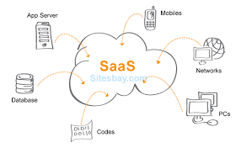

## **Conclusion:**

In today’s digital environment, cloud computing provides various models to suit different organizational needs. While **On-Premises** provides complete control, it comes with high costs and maintenance. **IaaS** offers foundational flexibility, **PaaS** speeds up development, and **SaaS** ensures quick deployment and ease of use. Understanding their differences is essential for making strategic IT decisions that align with business goals.

